**Samba and NFS**

**Samba**

Sudo apt install samba //install samba

Sudo systemctl status smbd //check status of samba

cp /etc/samba/smb.conf /etc/samba/smb.conf.ori //make backup copy

1. Add a new user to the server. The following directories should be added to new user’s home directory automatically when it is created.

* smbwork
* nfsdoc

Command (add new user): sudo adduser user

How to add files/directories to user’s home directory during creation?

Useradd -d /etc/skel -m smbwork

User add -d /etc/skel -m nfsdoc

1. Add a new section in samba configuration. Use the new user name as the section name.

File to edit: add a section

[username]

Comment = Works sharing in server

Path = /home/royal/smbwork

Read only = no

Browseable = yes

Create mask = 0750

Attributes for the section:

* Comment is **Works sharing in server**
* Set the sharing path to the **smbwork** folder
* It is browsable and writable
* Newly created file / directory should be assigned with permission 0750

1. Check the new configuration for syntax error.

Command: /etc/ samba$ testparm

1. Make the new configuration takes effect.

Command: sudo systemctl start smbd //start OR sudo systemctl restart smbd //restart

1. Set the samba password for the new user.

Command: sudo smbpasswd -a user

1. Test the configuration by connecting from Ubuntu Desktop.

-Launch file explorer  
-click on other location

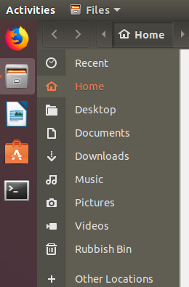

* Connect to Samba server from Ubuntu Desktop
  + The connection setting is located at the bottom of the window
  + 
  + Enter the server address, with the smb protocol
    - It can be IP address or domain name
    - 
* Click **Connect** and it will prompt for user name and password (password that set with smbpasswd)

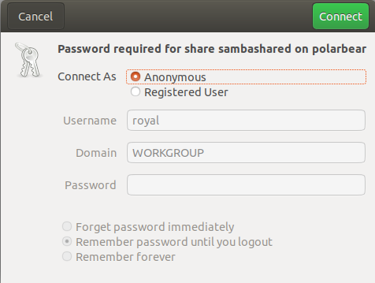

**NFS**

Sudo apt install nfs-kernel-server

Sudo cp /etc/exports /etc/exports.ori

1. Share the nfsdoc directory with NFS.

Configuration file to be edited: /var/nfsdoc

The directory should be writable through nfs. Only connection from the same subnet is allowed.

Configuration: /var/nfsdoc *(ro, fsid=0, no_subtree_check)

/var/nfs/backup 192.168.30.0/255.255.255.0 (rw,no_subtree_check)

/var/nfs/projects 192.168.30.0/24 (rw,no_subtree_check)

1. Make the new configuration take effect.

Command: sudo systemctl restart nfs-kernel-server

Sudo exportfs -a

* Connect to nfs:
  + Create a mount point. Example: sudo mkdir /mnt/nfsbackup
  + Use the **mount** command:

sudo mount *server_name*:/*dir_name* *mount_point*

* + - *server_name* can be replaced by server’s IP
    - Example: sudo mount 192.168.30.102:/backup /mnt/nfsbackup

1. Test the configuration from Ubuntu Desktop.

Command: